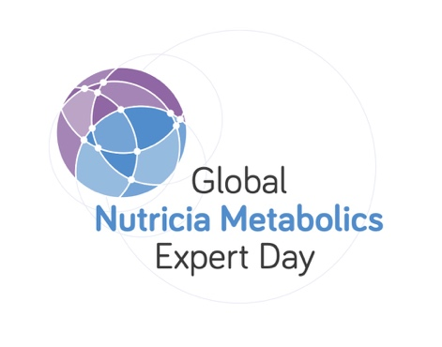

**SUMBIT YOUR IMD ABSTRACT FOR DAY 1**

**WEDNESDAY 20TH MARCH 2024**

For a chance to be one of five submissions specially selected by our scientific board to deliver a 10 minute, oral presentation as part of the program on the day itself, please submit an abstract of your case report or research on the topic of inherited metabolic disorders. Abstracts should be no more than **850 characters** in total including the name of the author and centre details and must be submitted before the deadline of 31ST January 2024. The five successful candidates will be informed by 1st February. There will be a poster display area available on the day for the remainder of the submissions.  
  
Any queries regarding abstract submissions please contact :  [clare.szwec@danone.com](mailto:clare.szwec@danone.com)

**Name of Presenting Author and Centre:**

**E-mail address:**

**Title of Abstract:**

**Co-Presenting Authors:**

**ABSTRACT (maximum 850 characters):**

**Deadline for submitting an abstract : Friday 5th January 2024 by email to** [**jmassociates1@me.com**](mailto:jmassociates1@me.com)

**Jacqui McAleer, JM Associates for Clare Szwec, Tel : +44 (0)7836650782**